1. 1. Show all data associated in salgrade table

SELECT \* FROM salgrade;

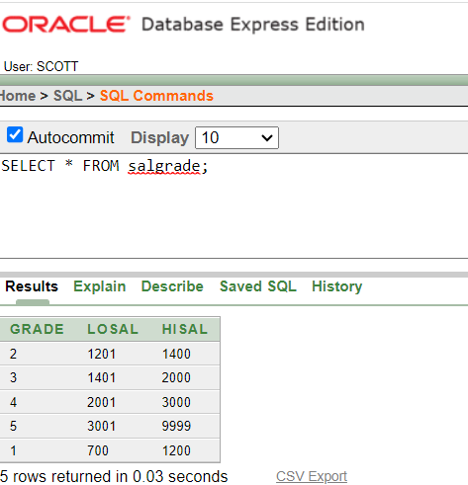

2. Show deptno from dept table

SELECT deptno FROM dept;

3. Show 5% increment of salary from emp table for each of the employee (ENAME, SALARY, 5% INCREMENT)

SELECT ENAME, SAL,SAL\*.05 AS "INCREMENT" FROM emp;

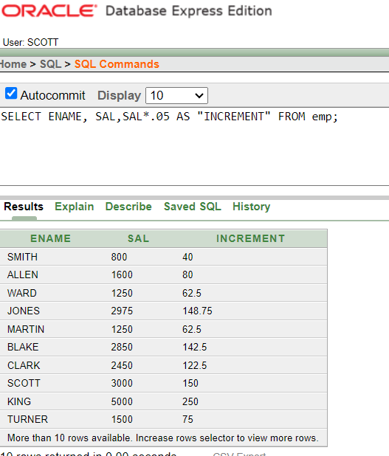

4. Show the new salary after increment (from 3) for each of the employee in emp table

SELECT ENAME, SAL, SAL+SAL \*.05 AS "INCREMENT" FROM emp;

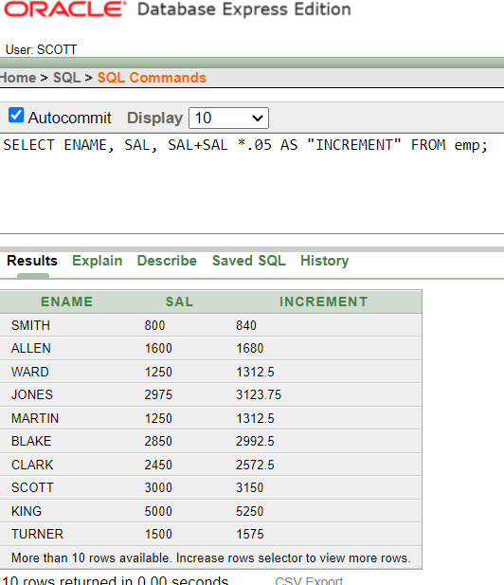

5. Show all the associated information of the employee named “BLAKE”.

SELECT \* FROM emp WHERE ENAME = 'BLAKE';

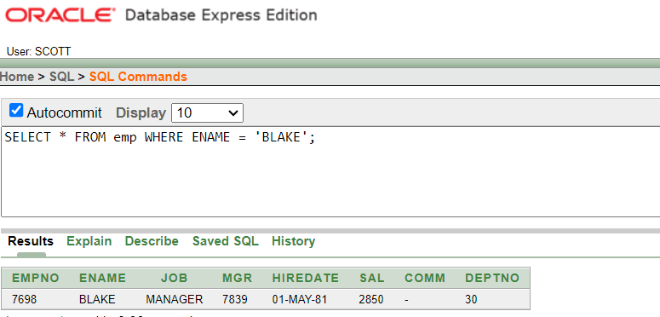

1. 6. Run the SQL COMMAND to show the following output

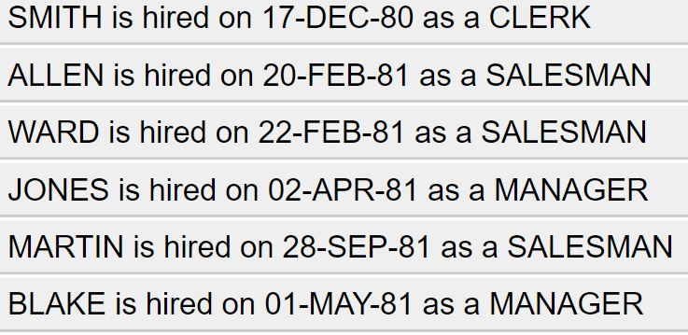

SELECT ENAME||' '|| 'is'||' '||'hired'||' '||'on'||' '|| HIREDATE||' '||'as'||' '||'a'|| JOB AS "Employee Hiredate"

FROM emp;

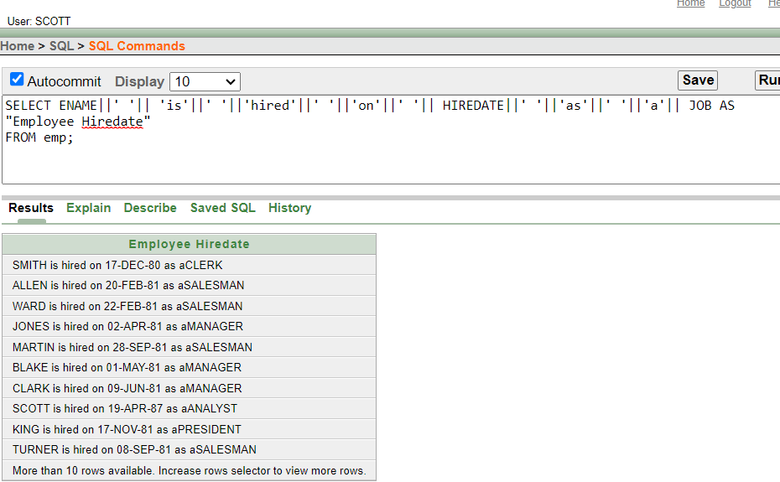

7. Show the description of all the four tables in the scott schema

describe emp;

describe dept;

describe bonus;

describe SALGRADE;

8. Show all the possible jobs from the emp table eliminating the duplicate instances or output

SELECT DISTINCT JOB FROM emp;

